Lesson 2.1: Integers and Rational Numbers.

Learning objectives for this lesson – By the end of this lesson, you will be able to:
- Graph and compare integers.
- Classify and order rational numbers.
- Find opposites of numbers.
- Find absolute values.

California State Standards Addressed: Algebra I (1.1, 2.0, 24.0, 25.1, 25.2)

2.1.1. Graph and compare integers.
Integers are the positive whole numbers, negative whole numbers and zero. There are an infinite number of integers. Examples of integers are {0, 3, 76, –2, –11, 995,…} and you may know them by the name whole numbers (although this term does not always include zero). When we represent integers on the number line they fall exactly on the whole numbers.

Example 1
Compare the numbers 2 and (–5)
First we will plot the two numbers on a number line:
1 2 3 4 5 6
-6 -5 -4 -3 -2 -1
0
The number –5
The number 2

We can compare integers by noting which is the greatest and which is the least. The greatest number is farthest to the right, and the least is farthest to the left.

In the diagram above we can see that 2 is farther right on the number line than –5, so we say that 2 is greater than –5. We use the symbol “>” to mean “greater than”.

Solution: 2 > –5

Example 2
A frog is sitting perfectly on top of number 7 on a number line. The frog jumps randomly to the left or right, but always jumps a distance of exactly 2. Describe the set of numbers that the frog may land on, and list all the possibilities for the frog’s position after exactly 5 jumps.

Solution:
We will graph the frog’s position, and also indicate what a jump of 2 looks like. We see that one possibility is that the frog lands on 5, another possibility is that it lands on 9. It is clear that the frog will always land on an odd number.
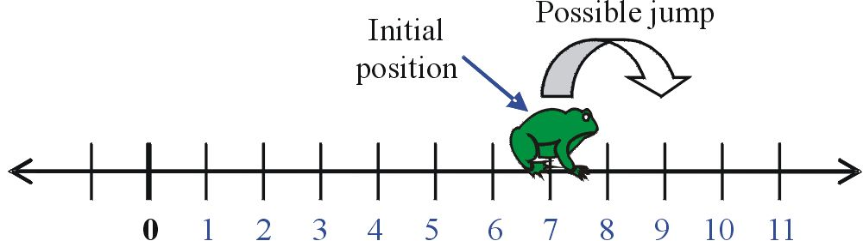

After 1 jump the frog could be on either 9 or 5 (but not 7). After 2 jumps the frog could be on 11, 7 or 3. Depending on how many times the frog jumps to the right or left, we may determine where the frog is. After 5 jumps there are many possible locations for the frog, but there is a systematic way to determine the possible locations by how may times the frog jumped right, and how many times the frog jumped left:
RRRRR = 5 × right location = 7 + (5 × 2) = 17
RRRRL = 4 × right, 1 × left location = 7 + (3 × 2) = 13
RRRLL = 3 × right, 2 × left location = 7 + (1 × 2) = 9
RRLLL = 2 × right, 3 × left location = 7 – (1 × 2) = 5
RLLLL = 1 × right, 3 × left location = 7 – (3 × 2) = 1
LLLLL = 5 × left location = 7 – (5 × 2) = –3
These are the possible locations of the frog after exactly 5 jumps.

2.1.2. Classify rational numbers.
When we divide an integer by another integer we get what we call a rational number: so called because it is the ratio of one number to another. For example if we divide one integer a by a second integer b the rational number we get is$\left(\frac{a}{b}\right)$. When we write our rational number like this the top number is called the numerator. The bottom number is called the denominator. You can think of the rational number as a fraction of a cake – if you cut the cake into b slices, your share is a of those slices.

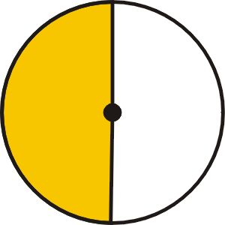
For example, when we see the rational number$\left(\frac{1}{2}\right)$, we imagine cutting the cake into 2 parts – our share is one of those parts. Visually, the rational number $\left(\frac{1}{2}\right)$looks like this:

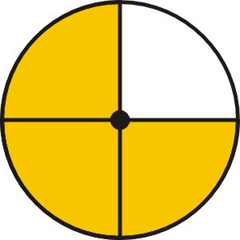
With the rational number$\left(\frac{3}{4}\right)$, we cut the cake into 4 parts and our share is three of those parts. Visually, the rational number $\left(\frac{3}{4}\right)$looks like this:

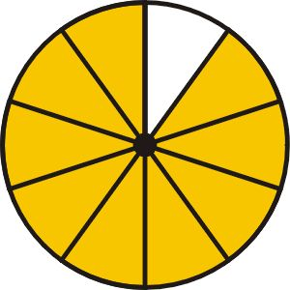
The rational number$\left(\frac{9}{\text{10}}\right)$ represents 9 slices of a cake that has been cut into 10 pieces. Visually, the rational number $\left(\frac{9}{\text{10}}\right)$looks like this:

Proper fractions are rational numbers where the numerator (the number on the top) is less than the denominator (the number on the bottom). A proper fraction represents a number less than one.
With a proper fraction you always end up with less than a whole cake!

Improper fractions are rational numbers where the numerator is greater than the denominator. Improper fractions can be rewritten as a mixed number – an integer plus a proper fraction. An improper fraction represents a number greater than one.

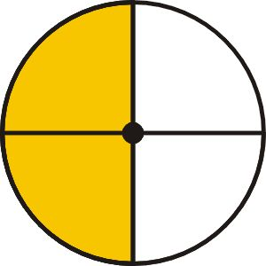
Equivalent fractions are two fractions that give the same numerical value when evaluated. For example look at a visual representation of the rational number$\left(\frac{2}{4}\right)$:

You can see that the shaded region is identical in size to that of the rational number$\left(\frac{1}{2}\right)$. We can write out the prime factors of both the numerator and the denominator and cancel matching factors that appear in both the numerator and denominator:
$\left(\frac{2}{4}\right)=\left(\frac{2⋅1}{2⋅2⋅1}\right)$ We then re-multiply the remaining factors: $\left(\frac{2}{4}\right)=\left(\frac{1}{2}\right)$

This process is called reducing the fraction. When we have cancelled all common factors we have a fraction in its simplest form.

Example 3
Classify and simplify the following rational numbers
a) $\left(\frac{7}{3}\right)$ b) $\left(\frac{9}{3}\right)$ c) $\left(\frac{\text{50}}{\text{60}}\right)$

a) 7 and 3 are both prime – there is no simper form for this rational number. 7 > 3 so…
Solution: $\left(\frac{7}{3}\right)$ is an improper fraction and is already in its simplest form.

b) 9 = 3·3 and 3 is prime. We rewrite the fraction thus: $\left(\frac{9}{3}\right)=\left(\frac{3⋅3⋅1}{3⋅1}\right)$. 9 > 3 so…
Solution: $\left(\frac{9}{3}\right)$ is an improper fraction and simplifies to$\left(\frac{3}{1}\right)$or simply 3.

c) 50 = 5·5·2 and 60 = 5·3·2·2. We rewrite the fraction thus: $\left(\frac{\text{50}}{\text{60}}\right)=\left(\frac{5⋅5⋅2⋅1}{5⋅3⋅2⋅2⋅1}\right)$. 50 < 60 so…
Solution: $\left(\frac{\text{50}}{\text{60}}\right)$ is a proper fraction and simplifies to$\left(\frac{5}{6}\right)$.

2.1.3. Order rational numbers.
Ordering rational numbers is simply a case of arranging numbers in order of increasing value. We write the numbers with the least (most negative) first and the greatest (most positive) last.

Example 4
Put the following fractions in order: $\left(\frac{1}{2}\right)$, $\left(\frac{3}{4}\right)$, $\left(\frac{2}{3}\right)$

Let’s draw out what each of these fractions look like:
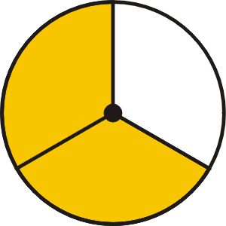
$\left(\frac{1}{2}\right)$: $\left(\frac{3}{4}\right)$: $\left(\frac{2}{3}\right)$:

We can see visually that the largest number is $\left(\frac{3}{4}\right)$ and the smallest is$\left(\frac{1}{2}\right)$:
Solution: $\left(\frac{1}{2}\right)$ < $\left(\frac{2}{3}\right)$ < $\left(\frac{3}{4}\right)$

With simple fractions it is easy to order them: we know that one half is greater than one quarter, and we know that two thirds is bigger than one half. With more complex fractions, however we need to find a better way to compare:

Example 5
Which is greater, $\left(\frac{3}{7}\right)$ or $\left(\frac{4}{9}\right)$?
In order to determine this we need to find a way to rewrite the fractions so that we can better compare them. We know that we can write equivalent fraction for both of these. We need to make the denominators in our equivalent fractions to be the same. We are looking for the lowest common multiple of each of the denominators. This is called finding the lowest common denominator (LCD).

The lowest common multiple of 7 and 9 is 63. Our fraction will be represented by a shape divided into 63 sections. This time we will use a rectangular cake cut into 9 by 7 = 63 pieces:
9 columns
7
rows
7 divides into 63 nine times so:
3 of 7
rows
$\left(\frac{3}{7}\right)=\frac{9}{9}\left(\frac{3}{7}\right)=\left(\frac{\text{27}}{\text{63}}\right)$
$\left(\frac{\text{27}}{\text{63}}\right)$ is an equivalent fraction to $\left(\frac{3}{7}\right)$ and is shown visually here:
4 of 9 columns

9 divides into 63 seven times so:
$\left(\frac{4}{9}\right)=\frac{7}{7}\left(\frac{4}{9}\right)=\left(\frac{\text{28}}{\text{63}}\right)$
$\left(\frac{\text{28}}{\text{63}}\right)$ is an equivalent fraction to $\left(\frac{4}{9}\right)$ and is shown visually here:

By writing the fractions over a common denominator of 63 you can compare them.
$\left(\frac{4}{9}\right)$:
Solution: $\left(\frac{4}{9}\right)$ is greater than$\left(\frac{3}{7}\right)$.

Remember:
To compare rational numbers re-write them with a common denominator.

2.1.4. Find opposites of numbers.
Every number, except zero, has an opposite. On the number line, a number and its opposite are opposite each other – they are the same distance from zero, but they are on opposite sides:
1 2 3 4 5 6
-6 -5 -4 -3 -2 -1
0
These numbers are opposites
Example 6
Find the value of the following:
a) 3 + (–3) b) 5 + (–5) c) (–11.5) + (11.5) d) $\left(\frac{3}{7}\right)+\left(−\frac{3}{7}\right)$
Each of the pairs of numbers in the above example are opposites – the opposite of 3 is (–3), opposite of 5 is (–5), the opposite of (–11.5) is 11.5 and the opposite of $\left(\frac{3}{7}\right)$is$\left(−\frac{3}{7}\right)$.
Solution: The value of each and every sum in this problem is zero.

Example 7
Find the opposite of the following:
a) 19.6 b) $−\left(\frac{4}{9}\right)$ c) x d) xy² e) (x – 3)

Since we know that opposite numbers are on opposite sides of zero, we can simply multiply each expression by –1. This changes the sign of the number:
a) Solution: The opposite of 19.6 is –19.6

b) Solution: The opposite of $−\left(\frac{4}{9}\right)$is$\left(\frac{4}{9}\right)$

c) Solution: The opposite of x is –x

d) Solution: The opposite of xy² is –xy²

e) Solution: The opposite of (x – 3) is –(x – 3) = (3 – x)

Note: With the last example you must multiply the entire expression by –1: A common mistake in this example is to assume that the opposite of (x – 3) is (x + 3) – DO NOT MAKE THIS MISTAKE!
2.1.5. Find absolute values.
When we talk about absolute value, we are talking about distances on the number line. For example the number 7 is 7 units away from zero. The number –7 is also 7 units away from zero. The absolute value of a number is the distance it is from zero, so the absolute value of 7 is 7 the absolute value of –7 is also 7.

We write the absolute value of –7 like this: “ |–7| ”
We read the expression | x | like this: “the absolute value of x”

- Treat absolute value expressions like parentheses – if there is a sum or product inside the absolute value symbols evaluate it first.

- The absolute value of a number or expression is always positive or zero. It cannot be negative. With absolute value we are only interested in how far a number is from zero, and not the direction.

Example 8
Evaluate the following absolute value expressions
a) | 5 + 4 | b) 3 – | 4 – 9 | c) | –5 – 11 | d) –| 7 – 22 |

Remember to treat any expressions inside the absolute value sign as if they were inside parentheses, and evaluate them first:

a) 5 + 4 = 9 | 9 | = 9 Solution: | 5 + 4 | = 9

b) 4 – 9 = –5 | –5 | = 5 3 – 5 = –2 Solution: 3 – | 4 – 9 | = –2

c) –5 –11 = –16 | –16 | = 16 Solution: | –5 – 11 | = 16

d) 7 – 22 = –15 | –15 | = 15 –(15) = –15 Solution: –| 7 – 22 | = –15

Homework Problems:
- The tick-marks on the number line represent evenly spaced integers. Find the values of a, b, c, d and e.
0
21
a
b
c
d
e

- Determine what fraction of the whole each shaded region represents:
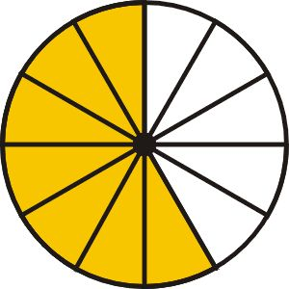
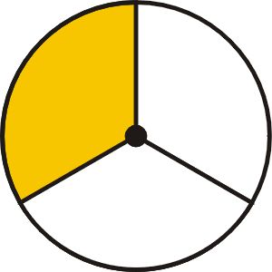
a) b) c)

- Place the following sets of rational numbers in order, from least to greatest:
a) $\frac{1}{2};\frac{1}{3};\frac{1}{4}$ b) $\frac{\text{11}}{\text{12}};\frac{\text{12}}{\text{11}};\frac{\text{13}}{\text{10}}$ c) $\frac{\text{39}}{\text{60}};\frac{\text{49}}{\text{80}};\frac{\text{59}}{\text{100}}$ d) $\frac{7}{\text{11}};\frac{8}{\text{13}};\frac{\text{12}}{\text{19}}$

- Find the simplest form of the following rational numbers:
a) $\frac{\text{22}}{\text{44}}$ b) $\frac{9}{\text{27}}$ c) $\frac{\text{12}}{\text{18}}$ d) $\frac{\text{315}}{\text{420}}$

- Find the opposite of each of the following
a) 1.001 b) (5 – 11) d) (x + y) d) (x – y)

- Simplify the following absolute value expressions
a) 11 – | –4 | b) | 4 – 9 | – | –5 | c) | –5 – 11 |

d) 7 – | 22 – 15 – 19 | e) –| –7 | f) | –2 – 88 | – | 88 + 2 |

Answers
1. a = –3; b = 3; c = 9; d = 12; e = 15
2. a = $\frac{1}{3}$; b = $\frac{7}{\text{12}}$; c = $\frac{\text{22}}{\text{35}}$
3. a) $\frac{1}{4}<\frac{1}{3}<\frac{1}{2}$; b) $\frac{\text{11}}{\text{12}}<\frac{\text{12}}{\text{11}}<\frac{\text{13}}{\text{10}}$; c) $\frac{\text{59}}{\text{100}}<\frac{\text{49}}{\text{80}}<\frac{\text{39}}{\text{60}}$; d) $\frac{8}{\text{13}}<\frac{\text{12}}{\text{19}}<\frac{7}{\text{11}}$
4. a) $\frac{1}{2}$; b) $\frac{1}{3}$; c) $\frac{2}{3}$; d) $\frac{3}{4}$
5. a) –1.001; b) 6; –(x + y); d) (y – x)
6. a) 7; b) 0; c) 16; d) –5; e) –7; f) 0

